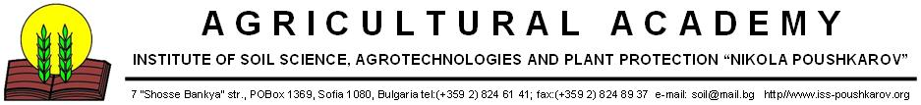

Invitation
For participation in the International Conference “AGRICULTURE AND AGROTECHNOLOGY IN A CHANGING WORLD”
Dear colleagues,
The Institute of Soil Science, Agrotechnologies and Plant Protection “N. Pushkarov” is organizing jointly with the Bulgarian Soil Science Society, Academy of Agriculture, Ministry of Agriculture and Food, an International Conference “AGRICULTURE AND AGROTECHNOLOGY IN A CHANGING WORLD” that will be held in Sofia in May 11 – 15, 2015.
The Conference is organized to celebrate declared by the UN General Assembly 2015 – The International Year of the soil, 140-th anniversary of the birth of Nikola Pushkarov and 85-th anniversary of publishing the Map of Soil Types in Bulgaria
The main topics of the International Conference on which abstracts and papers will be submitted are:
- Modern knowledge of soils. Genesis, diagnostics and classification
- Land use and agrotechnology for sustainable environment
- Sustainable management of soil and water resources
- Soil and plant health under climate change
- Modern policies for soils and waters
We aim to publish the conference proceedings in a special volume. Selecting the submitted abstracts and safeguarding the quality of the submitted papers is the main responsibility of the Scientific Committee while the editorial work for the proceeding will be done by specially selected group.
On behalf of the Organizing Committee I am pleased to cordially invite you to join the International Conference “AGRICULTURE AND AGROTECHNOLOGY IN A CHANGING WORLD” from 11 May till 15 May 2015.
With kind regards,

Prof. Dr. Totka Mitova
Chair of the Organizing Committee
of the International Conference “AGRICULTURE AND AGROTECHNOLOGY IN A CHANGING WORLD”

